Experiment 33:
Aim:
33.Write a Python program to draw a scatter plot with empty circles taking a random distribution in X and Y and plotted against each other.
Python code:
import matplotlib.pyplot as plt
import numpy as np

# Generate random distribution for X and Y
np.random.seed(19680801)
x = np.random.randn(100)
y = np.random.randn(100)

# Draw scatter plot with empty (unfilled) circles
plt.scatter(x, y, s=80, facecolors='none', edgecolors='b')

# Add labels and title
plt.xlabel('X-axis')
plt.ylabel('Y-axis')
plt.title('Scatter Plot with Empty Circles')

plt.show()
Output:
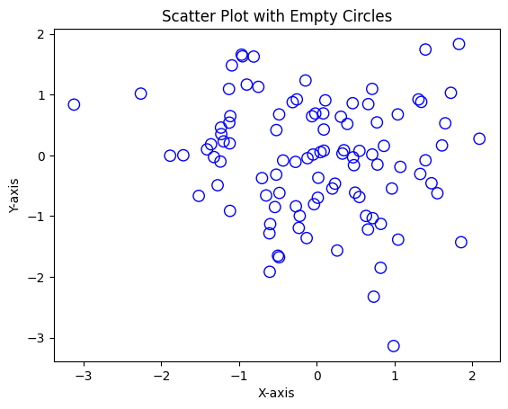
Experiment 34:
Aim:
34.Write a Python program to draw a scatter plot using random distributions to generate balls of different sizes.
Python code:
import matplotlib.pyplot as plt
import numpy as np

# Generate random distribution for X, Y and ball sizes
np.random.seed(19680801)
x = np.random.rand(50)
y = np.random.rand(50)
sizes = np.random.rand(50) * 1000 # different sizes for each ball
colors = np.random.rand(50)

# Draw scatter plot with balls of different sizes
plt.scatter(x, y, s=sizes, c=colors, alpha=0.5, cmap='viridis')

# Add labels and title
plt.xlabel('X-axis')
plt.ylabel('Y-axis')
plt.title('Scatter Plot with Balls of Different Sizes')

plt.show()
Output:
